Operate manual & Parts manual
Hand Pallet Truck with AC Pump
AC50-H

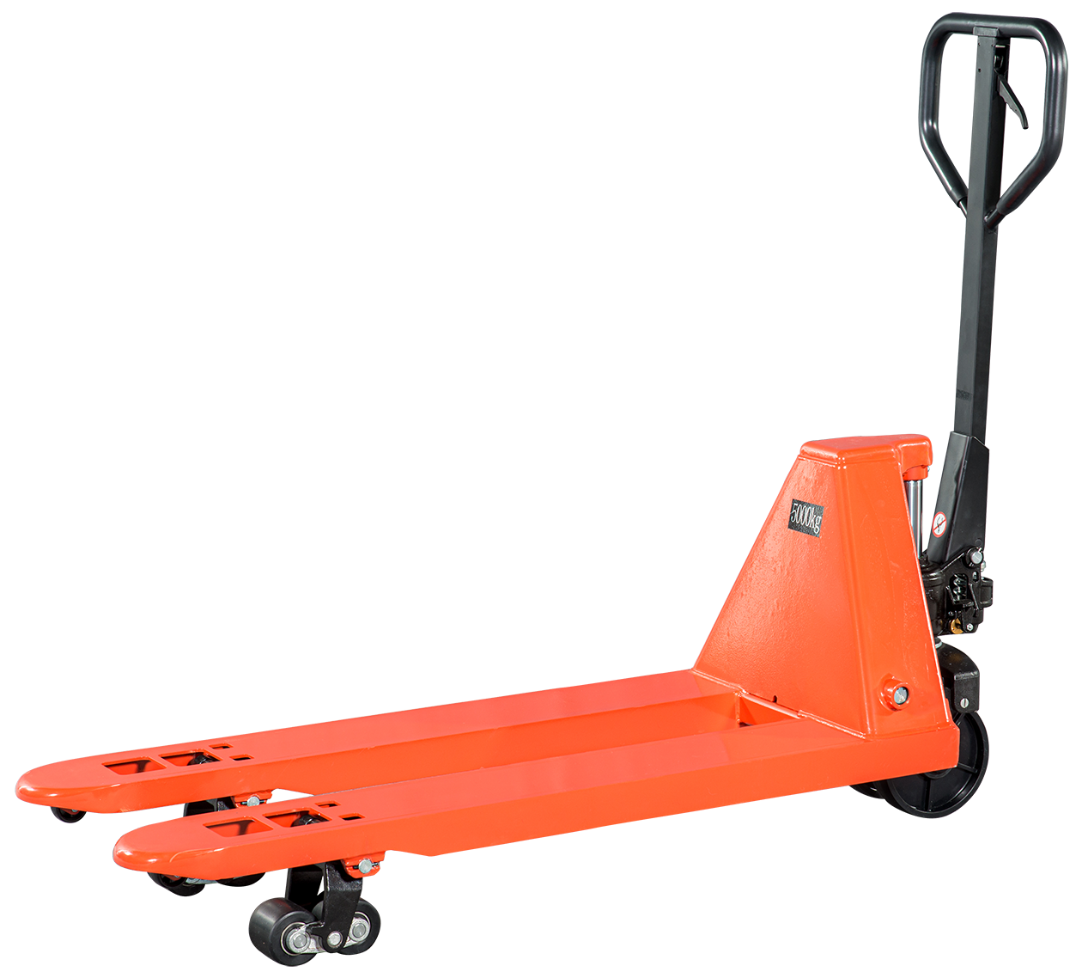

WARNING
Must read this manual before use
And various warning stickers on the manual hydraulic truck.
Keep for future reference!

Table of Contents
Safety instructions
Safety notice·················································································································1
Instructions for use
Specifications················································································································2
Install the handle············································································································2
Installation Precautions····································································································3
Installation steps·············································································································3
Handle adjustment··········································································································4
Maintain
Hydraulic oil······························································································.····················4
Exhaust air····················································································································5
Daily inspection and maintenance······················································································5
lubricating·····················································································································5
Troubleshooting···········································································································5
Parts catalog················································································································7

Safety instructions
For your safety and proper use of the vehicle ,please read and understand this manual and all warning labels on the vehicle before the first operation .To ensure that help is available at all times ,this manual should be available for reference whenever necessary .
Note :For continuous product improvement ,the manufacturer reserves the right to change its product design and specifications without prior notice .If you want to know the latest product parameters ,please contact us .All parameters of this manual are subject to the date of publication of the manual .

1.The waste packages should be sorted and put into solid dustbins according to the materials and be collected disposal by local special environment protection bureau. To avoid pollution, it’s forbidden to throw away the waste randomly.

2.To avoid pollution during the use of the products, the user should prepare some absorbable materials (scraps of wooden or dry duster cloth) to absorb leaking oil in time. To avoid second pollution to the environment, the used absorbable materials should be handed in to special departments in terms of local authorities.

Safety notice
1.It is forbidden to operate the hydraulic carrier until necessary training, full familiarity with the hydraulic carrier and authorized operation are obtained.

2.Before operation, pay attention to check the vehicle, especially the state of wheel, handle assembly, fork frame and swing rod.

3.Do not use the truck on muddy and uneven ground.

4.Do not place any part of your body near the mechanical lifting parts of the vehicle, on the loaded goods and under the fork.

5.No carrying persons.

6.The operator should wear labor protection gloves for protection.

7.Do not use this vehicle to handle loose and unbundled goods.

8.Do not overload.

9.When handling the cargo, please pay attention to place the cargo in the center of the fork, and do not put the load at the end of the fork.

10.Only when the load weight is evenly distributed on the fork, can the vehicle be used to its maximum load capacity.

11.Please make sure that the fork length is equal to or greater than the length of the pallet.

12.When not in use, please lower the fork to the lowest height.

13.In some special cases or places, the operator should be careful and operate carefully.

Instructions for use
Please read this page carefully before use to familiarize yourself with the functions and debugging methods of the machine
Specifications
Model No. | AC50-H
Capamy (Kg) | 5000
Total lift height (mm) | 195
Lowered fork height (mm) | 85
Fork length (mm) | 1150/1220/1500/1800/2000
Width over the forks (mm) | 550/685
Steering wheel (mm) | Φ200X50
Fork wheel (mm) | Φ80X75
Truck weight (Kg) | 128
The company also provides special specifications of folk length ,such as：
800,900,950,1000,1500,2000mm.
Materials and specifications are subject to change without prior notice.

Install the handle
If you purchase a manual hydraulic truck packed with wooden pallet, you need to do some simple installation before using it. During installation, you may need some tools, such as a hammer, a pair of pliers, etc.; in addition, you need some accessories: a shaft with hole, two elastic pins (Note: one has been installed on the shaft (230)), both of which are packed in a plastic bag and wrapped on the handle with tape.
Note: the number on the handle wrapping paper must be consistent with that on the frame body wrapping paper.
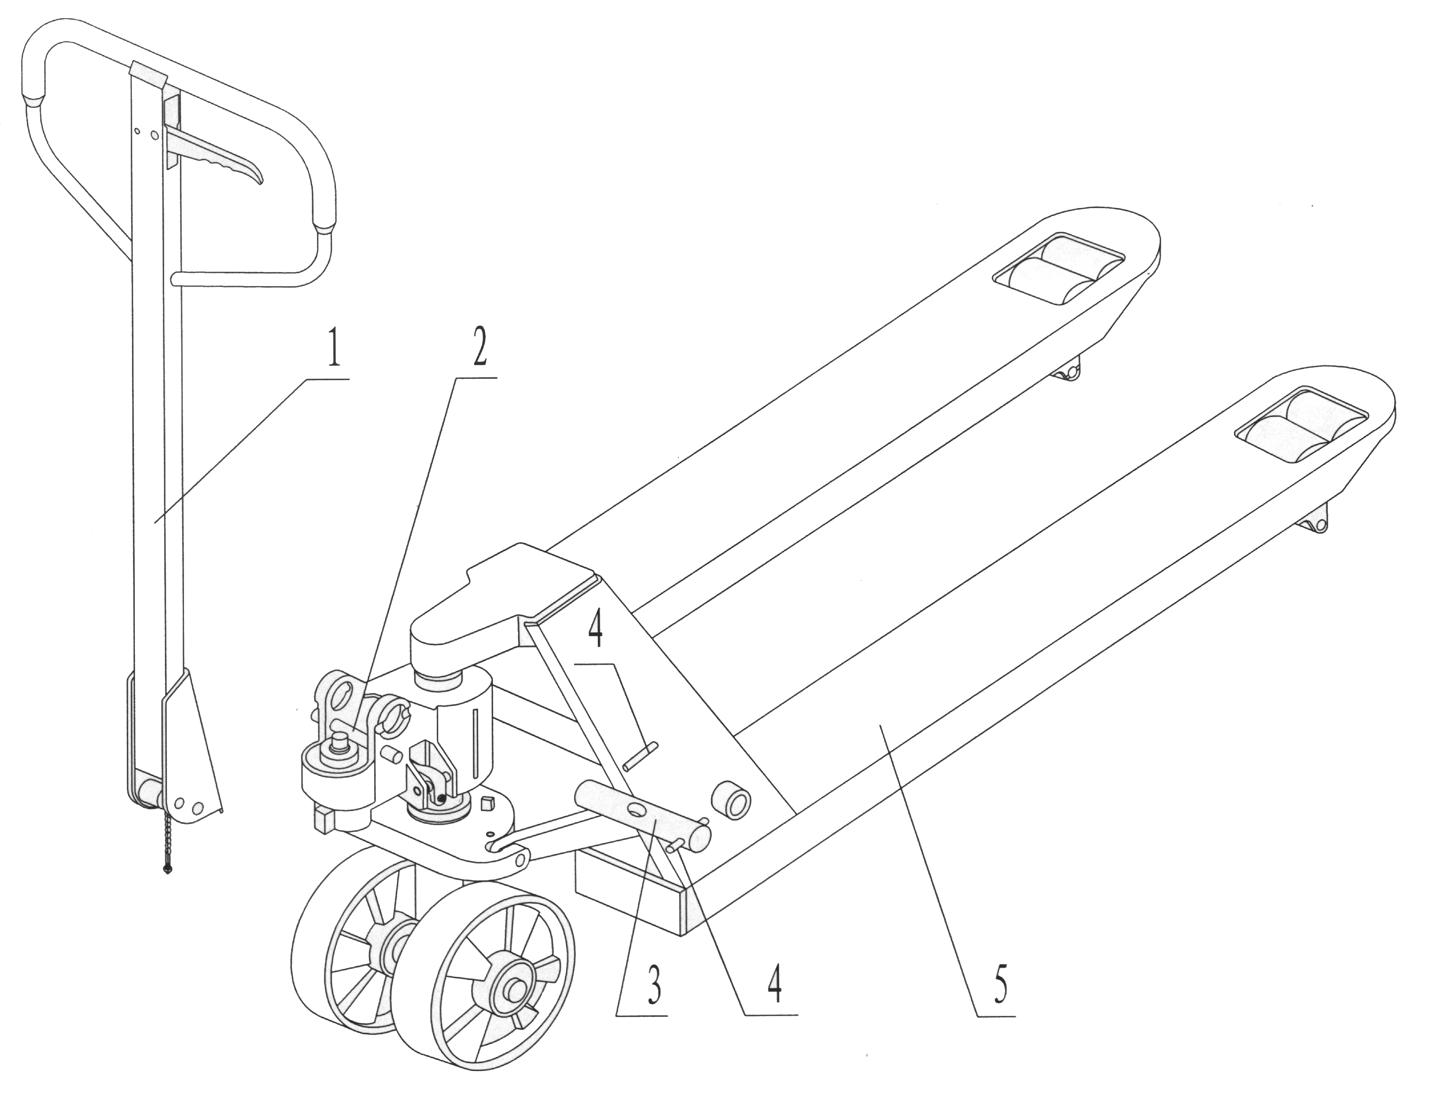

chapter. 1
1. handle 2. Dowel pin 3. Perforated pin 4. Spring pin 5. 1 Chassis

Installation Precautions

When you install the handle, it is better to squat at the rear of the vehicle, and then install it according to the following steps:

Installation steps

1. Place the handle on the small piston (303) and tap with a hammer so that the perforated shaft (230) enters the hydraulic oil pump and handle from right to left. (see Figure 2)
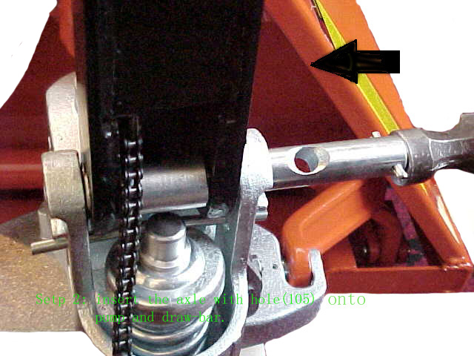

2. Place the control handle (117 or 120g) to the "down" position
chapter. 2 and allow the adjusting bolt (103),adjusting nut (104) and
chain (102) to pass through the central hole of the shaft (230)。
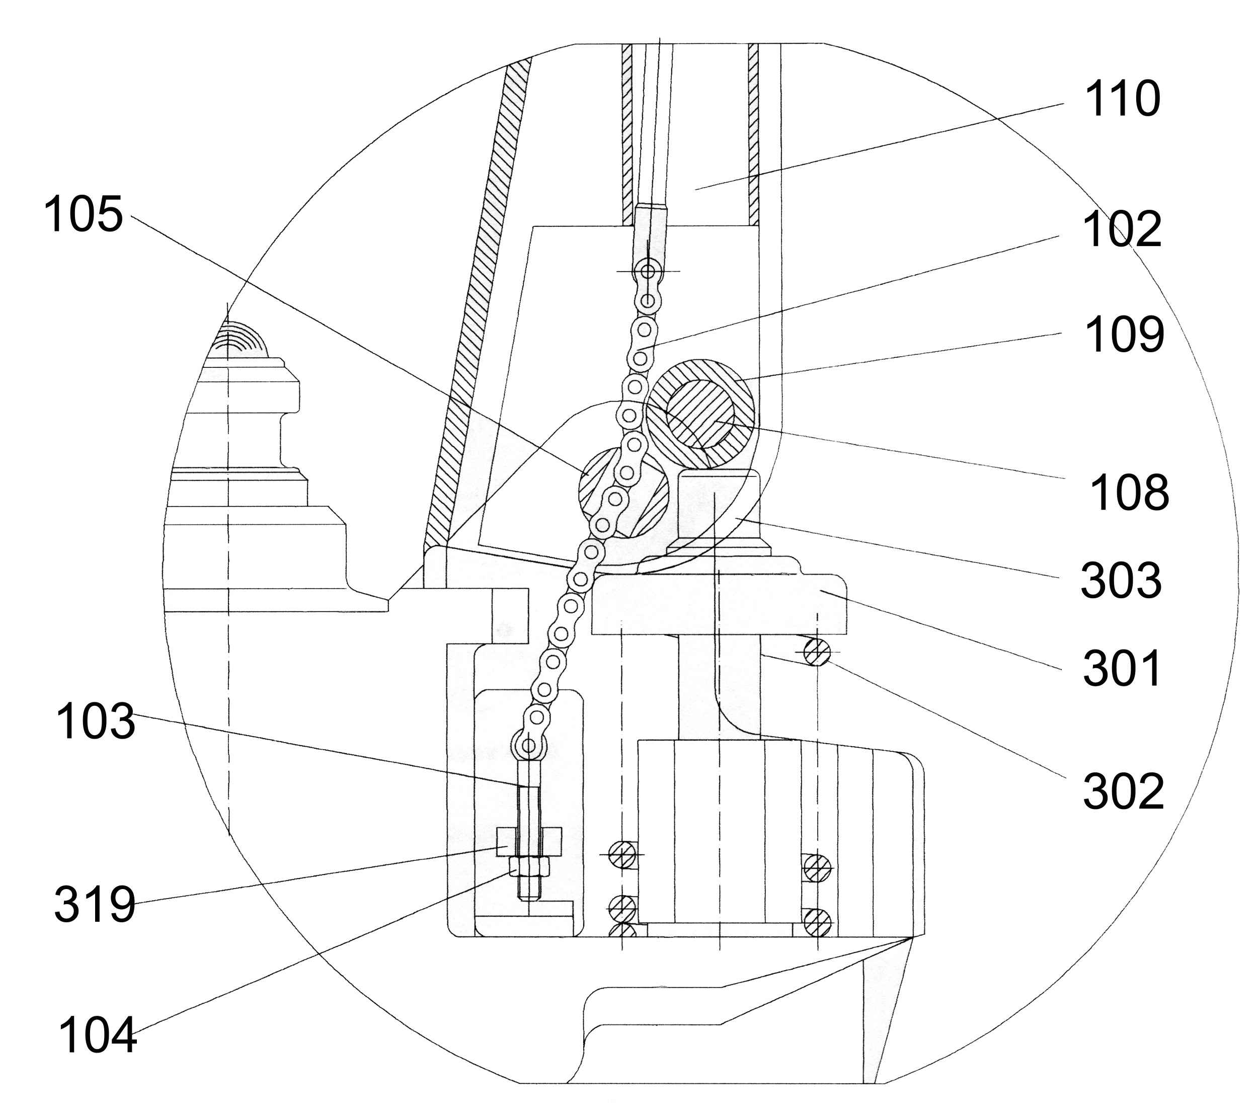
chapter. 1

图 3

chapter. 3

3.Press down the handle (110,) and remove the pin (#2) (see Fig. 1)

4. Put the control handle (117 or 120g) to the "lifting" position, pull up the swing rod (319), put the adjusting bolt (103) into the slot at the front end, and let the adjusting nut (104) stick to the lower end (319) of the swing rod.

5. 5 Drive the elastic pin (231) into the perforated pin shaft (230) with a hammer.
So the handle is installed.

Adjustment of three positions (up, middle and down) of finger handle

On the handle of the carrier, you will see that the finger control handle has three position states, and
its functions are as follows

Raise - control the handle at the lower part. When the handle is swinging up and down, the fork will rise.

Neutral- the control handle is in the middle. Swing the handle up and down. The fork does not rise or fall. It is used to pull the vehicle.

Lower- the control handle is on the upper part. At this time, the fork descends. Release the control handle and return to the middle position automatically.

The three positions of the finger handle have been adjusted before delivery. If there is any change due to unexpected reasons, the following steps can be followed:

1.if the finger control handle is pressed in the middle position and the forklift rises, turn the adjusting screw (318) or the adjusting nut (104) on the adjusting bolt (103) clockwise until the fork does not rise or fall when pressing.

2.if the fork is lowered when the finger control handle is in the middle position, turn the adjusting screw (318) or adjusting nut (104) anticlockwise until the fork does not descend.

3.When the finger control handle (117 or 120g) is in the down position and the fork does not descend, turn the adjusting screw (318) or the adjusting nut (104) clockwise until the fork is lowered when the finger control handle is in this position. Then check the middle position according to items 3.1 and 3.2 to ensure the correct function of the middle position.

4.If the finger control handle is pressed at the rising position, the fork will not rise. Turn the adjusting screw (318) or adjusting nut (104) anticlockwise until the fork rises. Then according to 3.1, 3.2 and 3.3, check whether the function of descending and median is normal.

Maintain
In order to ensure that the machine can be used normally, please follow the maintenance
instructions below for machine maintenance.
Hydraulic oil
Check the oil quantity every six months. The total amount is about 0.3 liters. Select hydraulic oil according to the table below

Temperature | Hydraulic oil
-20℃~+40℃ | L-HV46 Hydraulic oil

Exhaust air
Air may find its way into the pump during transportation, tilting or usage on uneven ground. It can result in not elevating forks whilst pumping in the Raise position. The air can be removed in the following way: Move the control handle（117 or 120G to the Lower position, then move the tiller down several times(110). Thereafter normal operation can be resumed.

Daily inspection and maintenance
The daily inspection and maintenance of the manual hydraulic carrier can improve the service life of the vehicle. Special attention should be paid to the wheels and axles to check whether there are cotton strips, etc., which will entangle the wheels. After the operation, the goods on the fork should be unloaded and the fork should be lowered to the lowest position.

Lubricating
All bearings and shafts are provided with long-life grease at the factory. Long-life grease should be applied to the lubrication points at monthly intervals or after each time the truck is cleaned.

Troubleshooting
Number | Fault description | Dause | Treatment method
1 | Fork frame can not reach the highest height, | -Hydraulic oil is not enough | Add oil
2 | Fork cannot be raised | -No hydraulic oil  -The hydraulic oil is impure  -The adjusting nut (104) is too high or the adjusting screw (318) is too close, causing the release valve to open  -Air in hydraulic oil | -Add oil  -Change hydraulic oil  -Readjust adjusting nut (104) or adjusting screw (318) (see 3.4)  -Exhaust air (see 4.2)
3 | The fork  frame cannot  be lowered.. | -The large piston (328) or pump body (322) is damaged due to the goods being placed to one side or overloaded  -When the fork frame is in the elevated position for a long time, the large piston is exposed and rusted, which hinders the piston movement.  -The adjusting nut (104) or adjusting screw (318) is not in the correct position. | -Replace large piston (328) or oil pump body (322)  -When not in use, please lower the fork bracket to the lowest position and lubricate the piston rod in time.  -Readjust adjusting nut (104) or adjusting screw (318) (see 3.3)
4 | Oil leakage | -Eal aging or damage  -Some parts break - | -Renew  -Update
5 | Fork self  lowering | -Hydraulic oil impurity causes the -Release valve cannot be closed tightly  -Some parts of the hydraulic system are broken or damaged  -Air mixed into the hydraulic oil  -Seal aging or damage  -Adjusting nut (104) or adjusting screw (318) not in correct position | -Oil change  -Check and renew  -Exhaust air (see 4.2)  -Renew it  -Readjust adjusting nut (104) or adjusting screw (318) (see 3.2)

Note: Do not attempt to repair the hydraulic truck without special training.

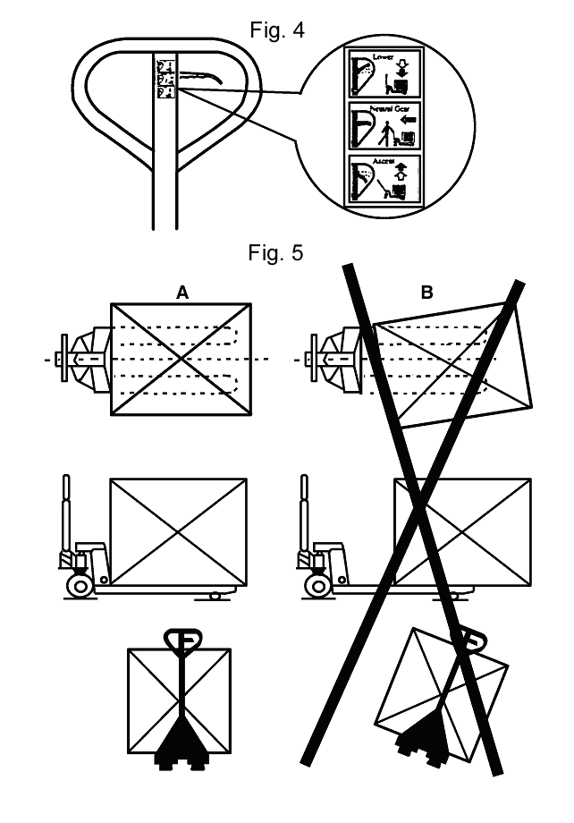

1, Handle parts

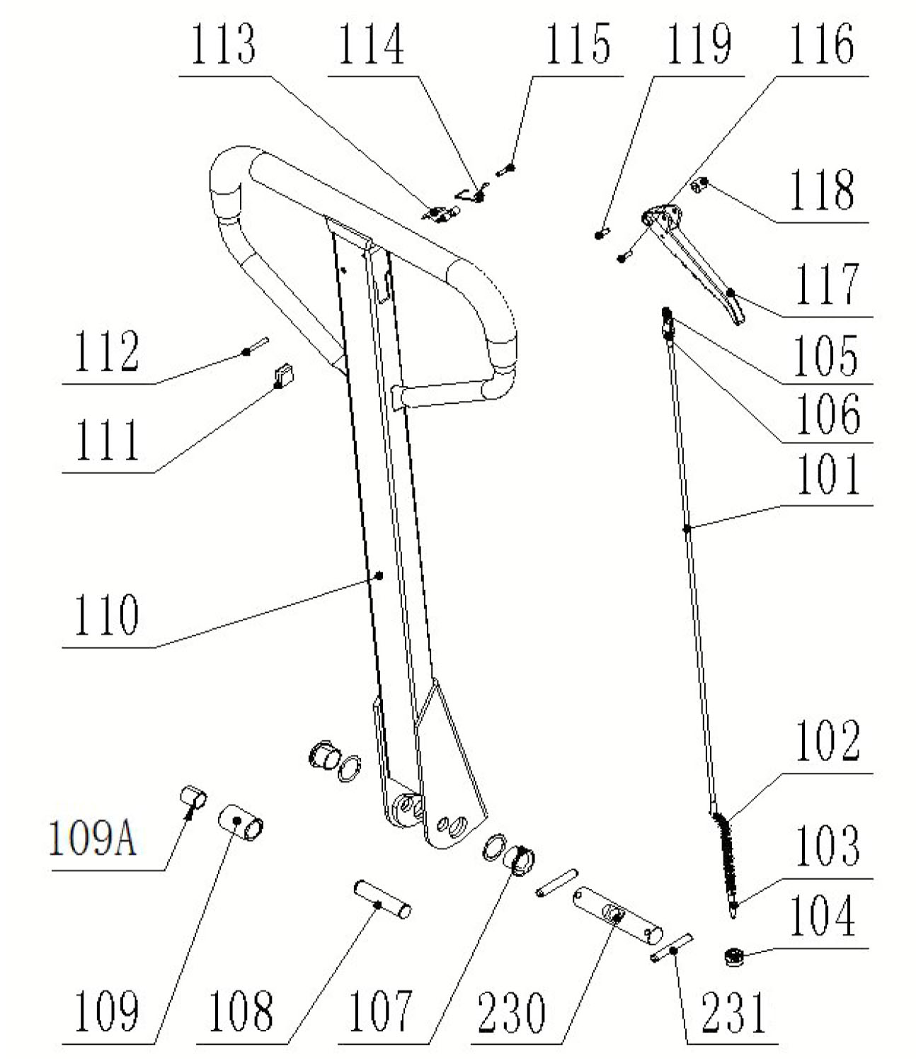
Item | Parts No. | Parts details | Qty. |  | Item | Parts No. | Parts details | Qty.
101 | 28010101 | Long connecting rod | 1 |  | 110 | 28010110 | Handle body | 1
102 | 28010102 | Roller chain | 1 |  | 111 | 28010111 | Rubber blanket | 1
103 | 28010103 | Adjust bolt | 1 |  | 112 | 28010112 | Spring pin | 1
104 | 28010104 | Adjust nut | 1 |  | 113 | 28010113 | Blade Spring | 1
105 | 28010105 | Connecting plate | 1 |  | 114 | 28010114 | Torsional spring | 1
106 | 28010106 | Plat conical head rivet | 1 |  | 115 | 28010115 | Spring pin | 1
107 | 28010107 | Bushing | 2 |  | 116 | 28010116 | Spring pin | 1
108 | 28010108 | Roller pin | 1 |  | 117 | 28010117 | The finger handle | 1
109 | 28010109 | Pinch roller | 1 |  | 118 | 28010118 | Idler wheel | 1
109A | 28010120 | Bushing | 1 |  | 119 | 28010119 | Spring pin | 1

2, Truck chassis parts

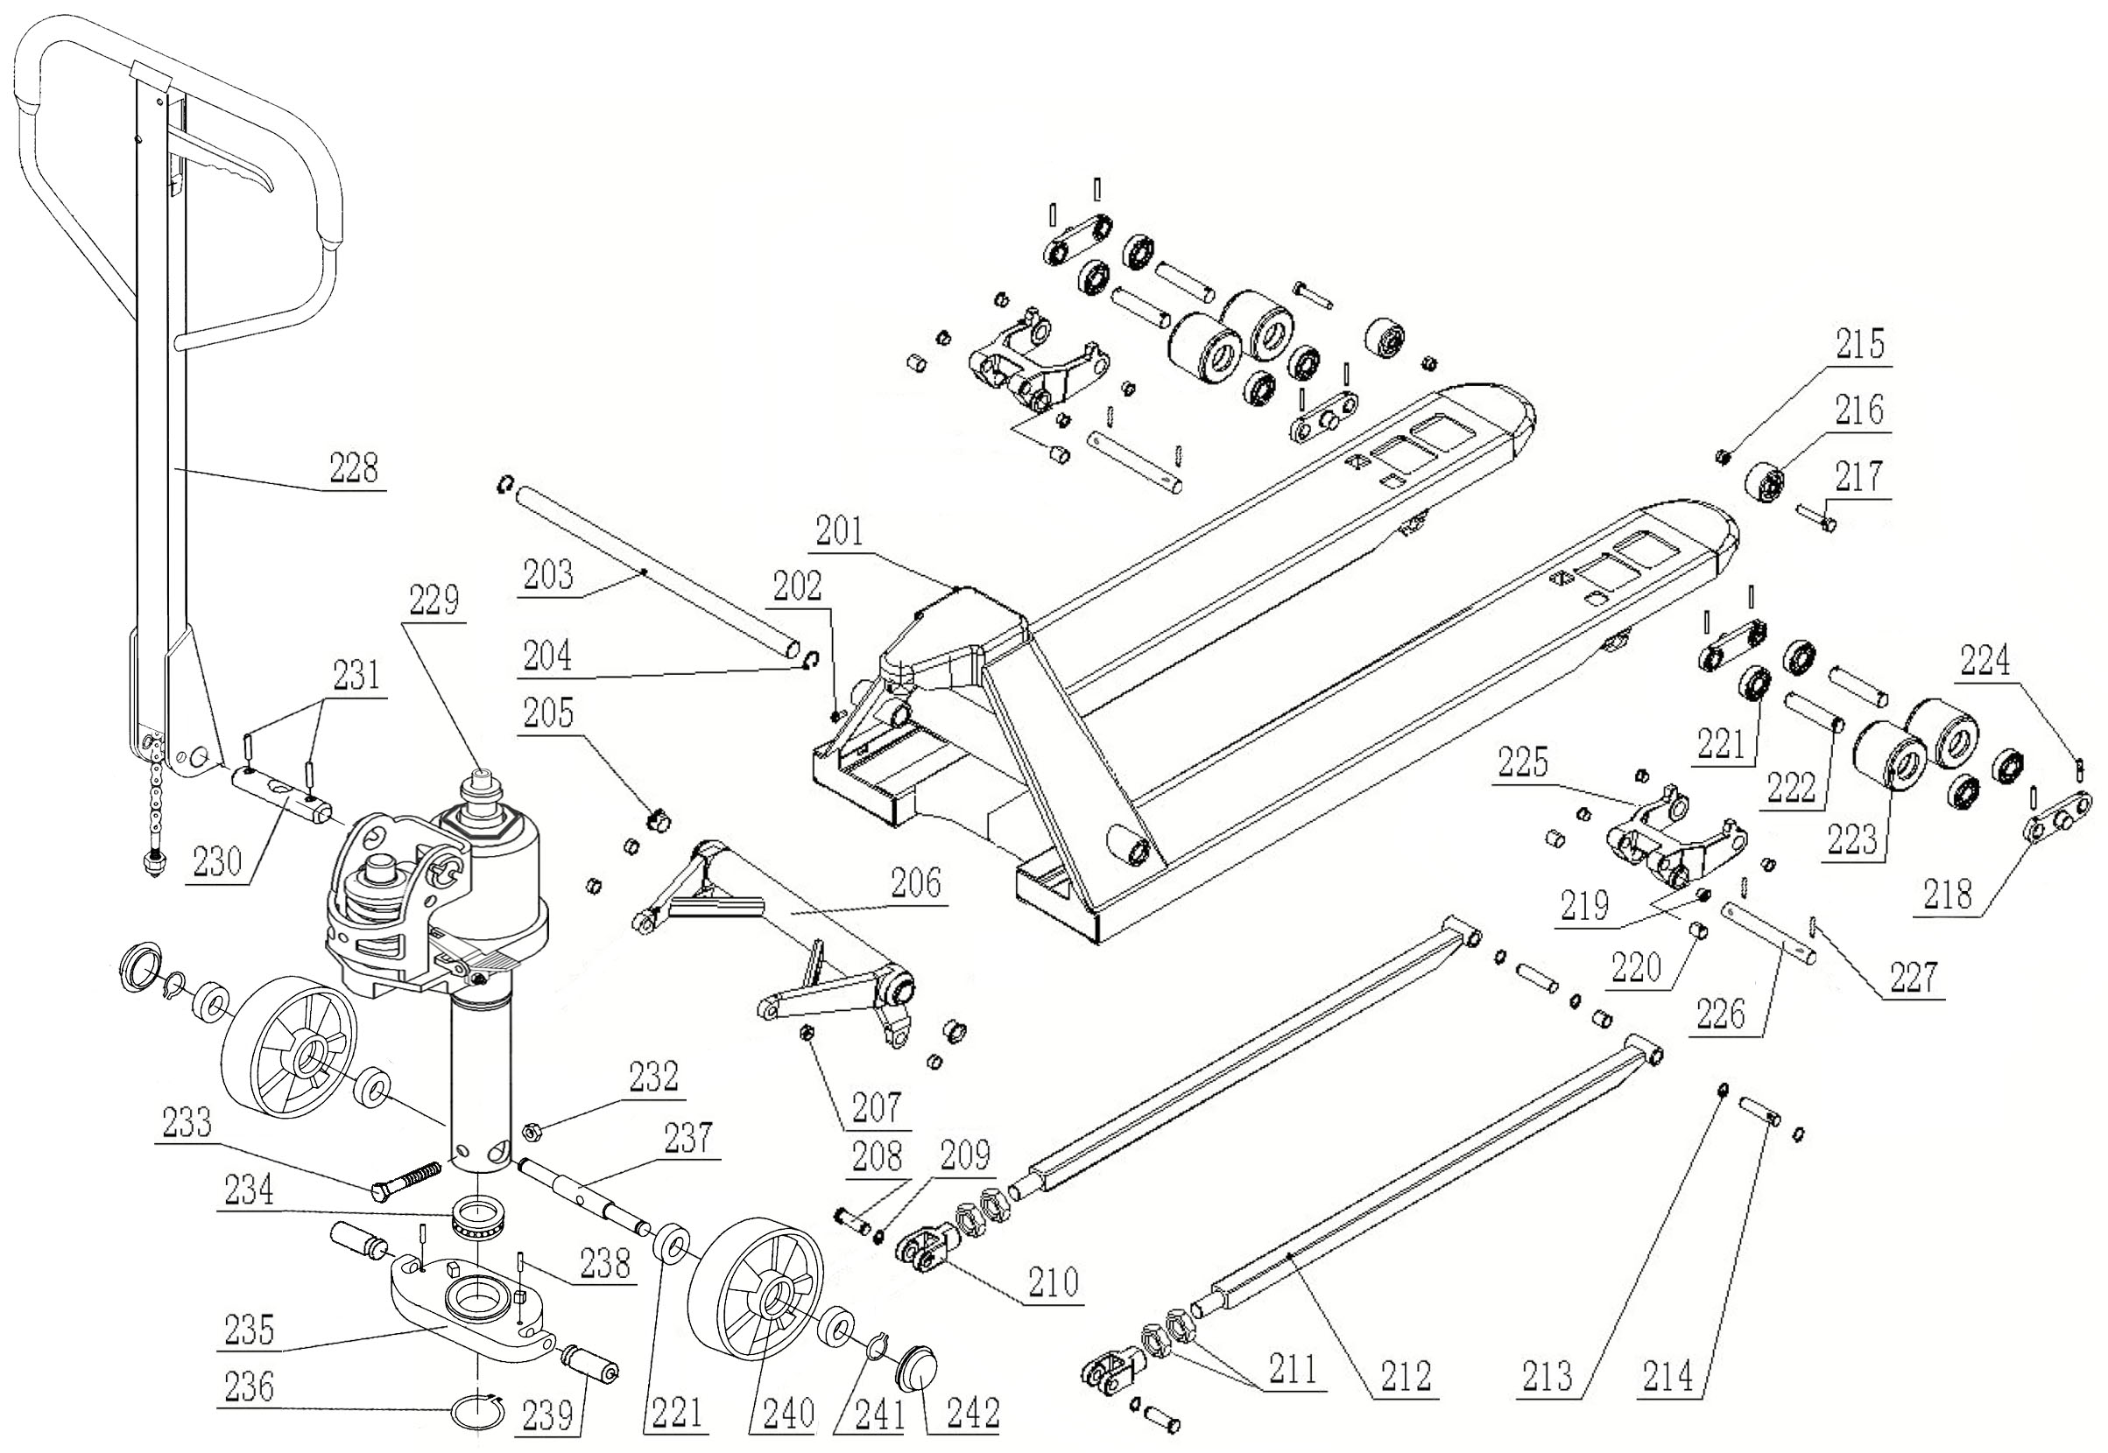
Item | Parts No. | Parts details | Qty. |  | Item | Parts No. | Parts details | Qty.
201 | 28010201 | Chasis and forks | 1 |  | 221 | 28010221 | Bearing 6204 | 8/12
202 | 28010202 | Bolt | 1 |  | 222 | 28010222 | Pin shaft 20*101 | 4
203 | 28010203 | Long axis 685 | 1 |  | 223 | 28010223 | Double loading wheel | 4
203 | 28010203-1 | Long axis 550 | 1 |  | 224 | 28010224 | Spring pin | 2
204 | 28010204 | Circlip | 2 |  | 225 | 28010225 | Wheel fork | 2
205 | 28010205 | Bushing | 2 |  | 226 | 28010226 | Pin shaft 20*170 | 4
206 | 28010206 | Rocker arm 685 | 1 |  | 227 | 28010227 | Spring pin | 2
206 | 28010206-1 | Rocker arm 550 | 1 |  | 228 | 28010228 | Handle assy. | 1
207 | 28010207 | Bushing | 4 |  | 229 | 28010229 | Pump assy. | 1
208 | 28010208 | Connecting pin 16*60 | 2 |  | 230 | 28010230 | Handle perforated pin | 1
209 | 28010209 | Check ring | 2 |  | 231 | 28010231 | Spring pin | 2
210 | 28010210 | The push rod fork | 2 |  | 232 | 28010232 | Caulking nut | 1
211 | 28010211 | Nut | 4 |  | 233 | 28010233 | Bolt | 1
212 | 28010212 | Push rod | 2 |  | 234 | 28010234 | Bearing | 1
213 | 28010213 | Circlip | 4 |  | 235 | 28010235 | Thrust strip | 1
214 | 28010214 | Shaft 16*112 | 2 |  | 236 | 28010236 | Circlip | 1
215 | 28010215 | Caulking nut | 2 |  | 237 | 28010237 | Shaft for steering wheel | 1
216 | 28010216 | Truckle | 2 |  | 238 | 28010238 | Spring pin | 2
217 | 28010217 | Bolt | 2 |  | 239 | 28010239 | Pin shaft 16*52 | 2
218 | 28010218 | Three consecutive plate | 4 |  | 240 | 28010240 | Steering wheel | 2
219 | 28010219 | Bushing | 8 |  | 241 | 28010241 | Scraper seal | 2
220 | 28010220 | Bushing | 2 |  | 242 | 28010242 | Retaining ring | 2
3, Pump parts
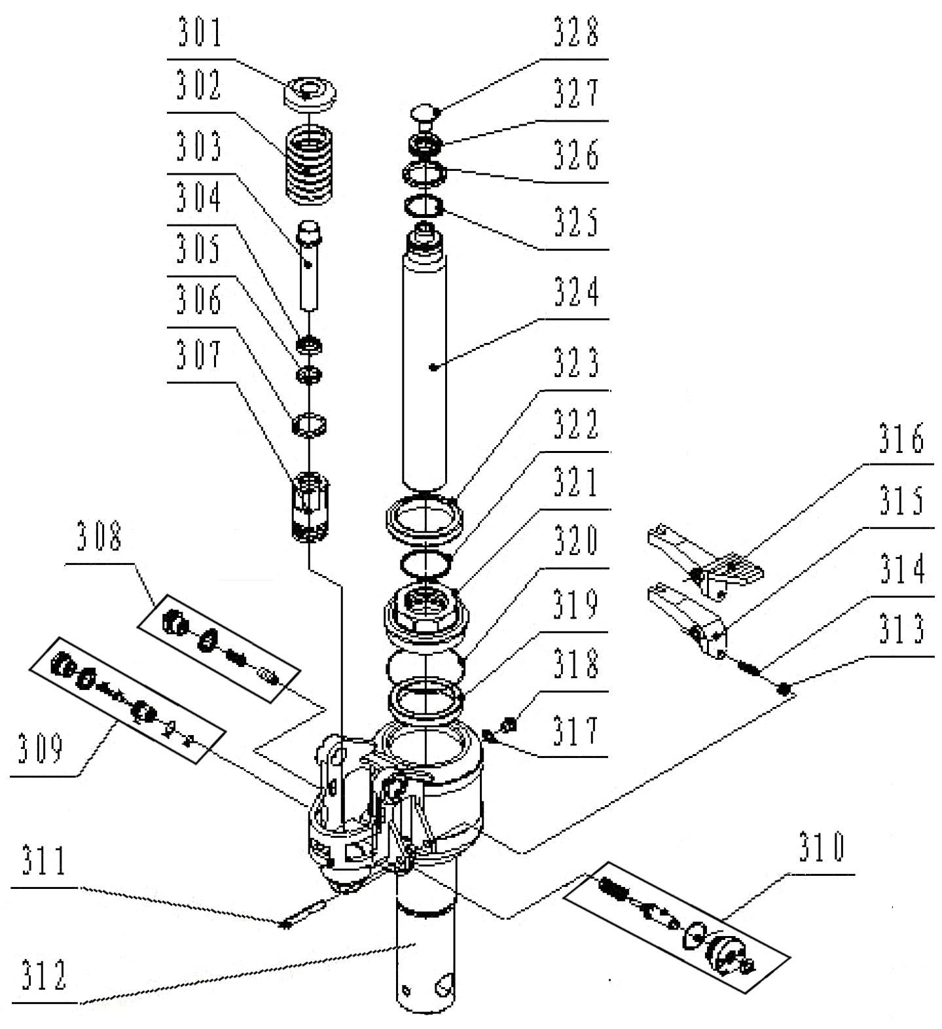
Item | Parts No. | Parts details | Qty. |  | Item | Parts No. | Parts details | Qty.
301 | 28010301 | Spring cover | 1 |  | 315 | 28010315 | Lever plate A type | 1
302 | 28010302 | Big spring | 1 |  | 316 | 28010316 | Lever plate B type(STD) | 1
303 | 28010303 | Small piston rod | 1 |  | 317 | 28010317 | Combination washer | 1
304 | 28010304 | Scraper seal | 1 |  | 318 | 28010318 | Plug | 1
305 | 28010305 | Y type circle | 1 |  | 319 | 28010319 | Scraper seal | 1
306 | 28010306 | Dust cap | 1 |  | 320 | 28010320 | O-Ring | 1
307 | 28010307 | Pump body | 1 |  | 321 | 28010321 | Cylinder cap | 1
308 | 28010308 | Safety valve assy. | 1 |  | 322 | 28010322 | O-Ring | 1
309 | 28010309 | Check valve assy. | 1 |  | 323 | 28010323 | Seal | 1
310 | 28010310 | Relief valve assy. | 1 |  | 324 | 28010324 | Piston rod | 1
311 | 28010311 | Spring pin | 1 |  | 325 | 28010325 | Circlip | 1
312 | 28010312 | Pump Base | 1 |  | 326 | 28010326 | Gasket | 1
313 | 28010313 | Nut | 1 |  | 327 | 28010327 | Bearing | 1
314 | 28010314 | Regulate screw | 1 |  | 328 | 28010328 | Top cap | 1

